Lab1.3 - Using Wireshark to Examine a UDP DNS Capture

Student Name: Mohamad Mostafa (ID: 30930)

Part 1: Record a PC’s IP Configuration Information

IPv4 Address: 192.168.1.104
Default Gateway: 192.168.1.1
DNS Server: 192.168.1.1
MAC Address: 9C-AD-97-30-57-CF

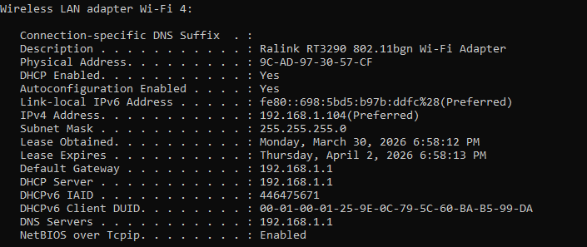

Part 2: Use Wireshark to Capture DNS Queries and Responses

Start Wireshark and Begin Capturing Data

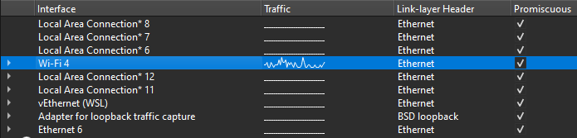

Opened https//www.google.com from the browser and stopped Capturing Data

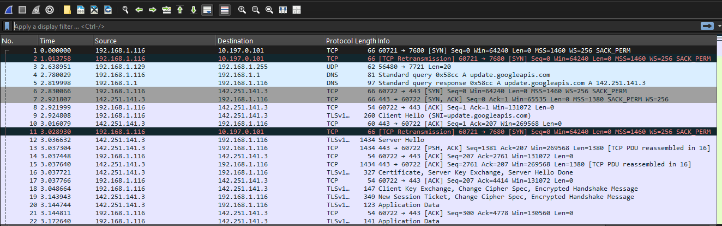

Part 3: Analyze Captured DNS or UDP Packets

Step 1: Filter DNS packets.

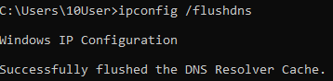

Standard query 0x92d9 A www.google.com

Step 2: Examine a UDP segment using DNS query.

Expanding Frame 504
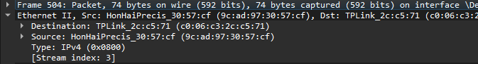
the source MAC address the same as the one recorded from Part 1 for the local PC

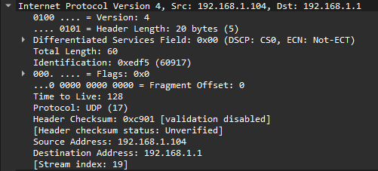
Local PC : IP Address: 192.168.1.104 - MAC Address : 9C-AD-97-30-57-CF
Default Gateway - IP Address: 192.168.1.1 - MAC Address : C0-06-C3-2C-C5-71

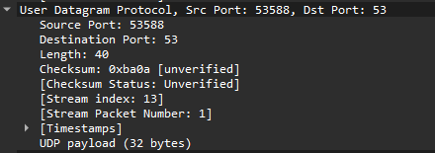

The source port number is 53588. The source port is randomly generated by the local PC using port numbers that are not reserved.
The destination port is 53.
Port 53 is a well-known port reserved for use with DNS. DNS servers listen on port 53 for DNS queries from clients.

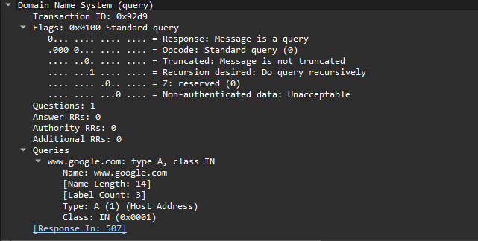

Frame Size (request) = 74 bytes.
The length of the UDP segment is 40 bytes. Out of 40 bytes, 8 bytes are used as the
header. The other 32 bytes are used by DNS query data.

the source IP address the same as the local PC IP address recorded in Part 1
the destination IP address the same as the default gateway noted in Part 1

Step 3: Examine a UDP using DNS response.

DNS Standard query
response 0x92d9 A www.google.com A 142.251.151.119

Expanding Frame 507
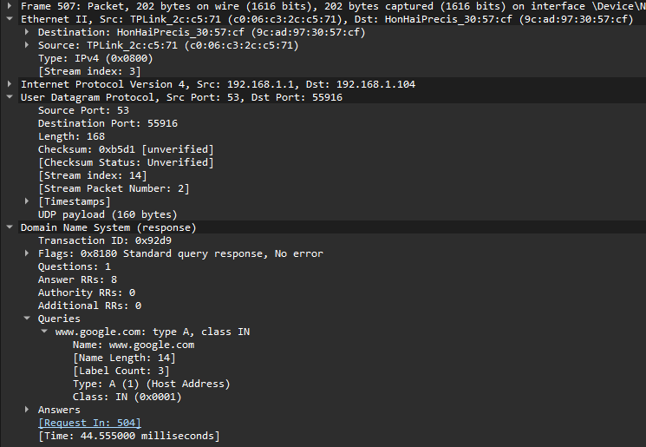

DNS response packet.
The number of bytes on the wire is 202. It is a larger packet compared to the DNS query packet (74 bytes).

In the Ethernet II frame for the DNS response, the default gateway is the source MAC address and
my local PC is the destination MAC address.

In the IP packet, the default gateway is the source IP address and my local PC is the destination IP address.
The roles has switched.

In the UDP segment, the role of the port numbers has also reversed.

The destination port number is 53588.
Port number 53588is the same port that was generated by the local PC when the DNS query was sent to the DNS server.
My local PC listens for a DNS response on this port.
The source port number is 53. The DNS server listens for a DNS query on port 53 and then sends a DNS response with a source port number of 53 back to the originator of the DNS query.

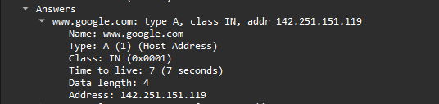

the resolved IP addresses for www.google.com is 142.251.151.119

Reflections
_______________________________
What are the benefits of using UDP instead of TCP as a transport protocol for DNS?
UDP is good for DNS because it has lower overhead than TCP. It does not require a three-way handshake. This makes DNS communication faster and more efficient.

UDP & DNS Graph Statistics

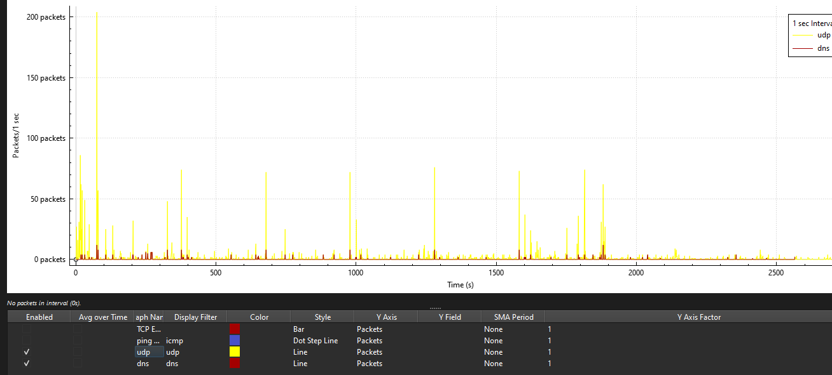

THANK YOU.
Mohamad Mostafa (ID: 30930)

